**What explains summer declines in Minneapolis Police Department activity?**

a memo by Jeff Hargarten and Kim Hyatt | July 21, 2020

**What we know from data:**

The social unrest, as characterized by demonstrations, rioting, upticks in gunfire and other criminal activity following the death of George Floyd is commonly thought to have stretched from May 25 to June 2.

[Prior analysis](https://www.startribune.com/following-historic-unrest-george-floyd-police-call-data-show-quieter-minneapolis/568966851/) of reports logged by Minneapolis police showed dramatic dropoffs in activity after curfews ended and all four officers involved in Floyd’s death were charged and arrested.

But these metrics were also noticeably lower compared to before Floyd’s death. While [gun violence is increasing](https://www.startribune.com/surge-in-gun-violence-tests-minneapolis-leaders/571524202/) and grabbing headlines, police activity in terms of recorded stops and crimes have been depressed.

This bucks expectations for summertime crime in Minneapolis. That surges in gun violence persisted while other recorded crimes fell suggested a broader trend. Readers reacting to previous reporting also recounted tales of unresponsive police, busy signals when calling 911, requests for service being refused over the scanner and delayed arrivals of officers to scenes – often for less serious, everyday calls.

So we requested dispatch assignments to Minneapolis police for 2019 and received them through July 13th of this year to measure how police activity has changed.

We have also requested all Minneapolis 911 calls from DPS, not just what gets assigned and responded to by MPD, but this is still pending.

**Calls have been gradually declining for a while**

From what we do currently know: police calls in Minneapolis – defined as service requests MPD officers respond to from dispatchers – have been declining each year since 2017, a 21% decrease by 2019’s end.

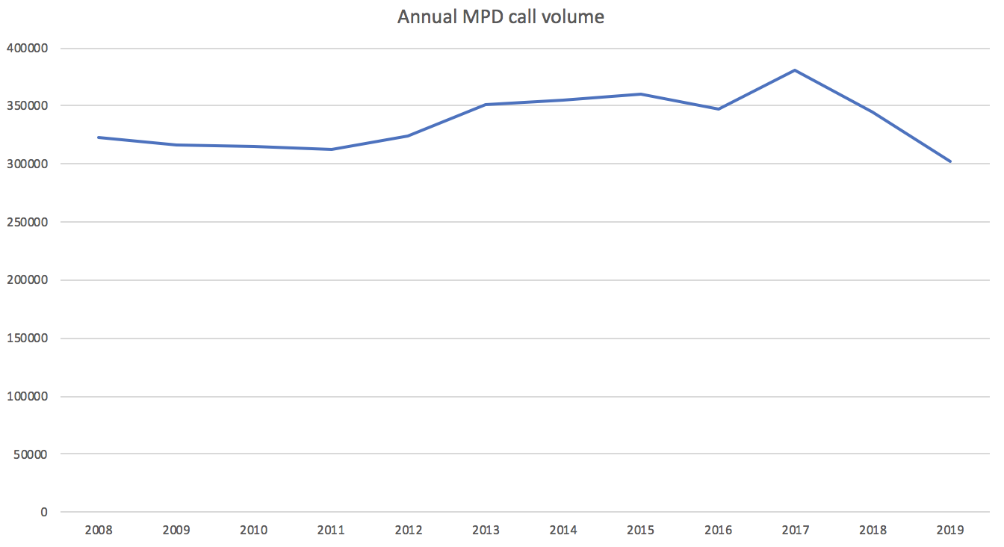

**But this summer’s activity is much flatter than usual**

A continuation of this trend may extend into this year – but doesn’t seem like a satisfactory explanation for this summer’s notable deflation in police activity that’s visible when zooming in on daily call volume.

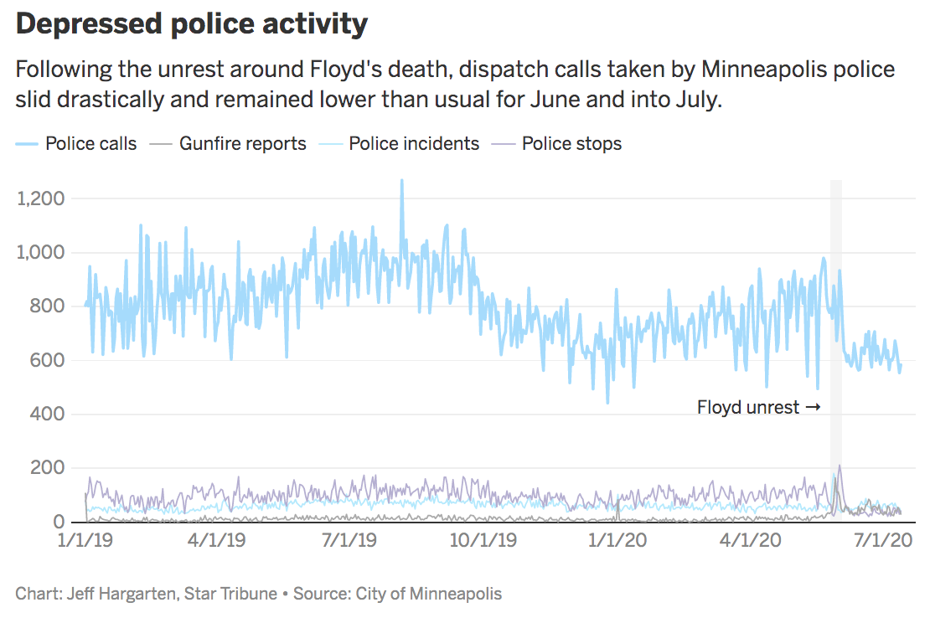

[View this chart in DataWrapper](https://datawrapper.dwcdn.net/78vFu/8/)

This flatlining of police activity becomes even clearer when examining this year’s daily call volume with a weeklong moving average applied.  
  
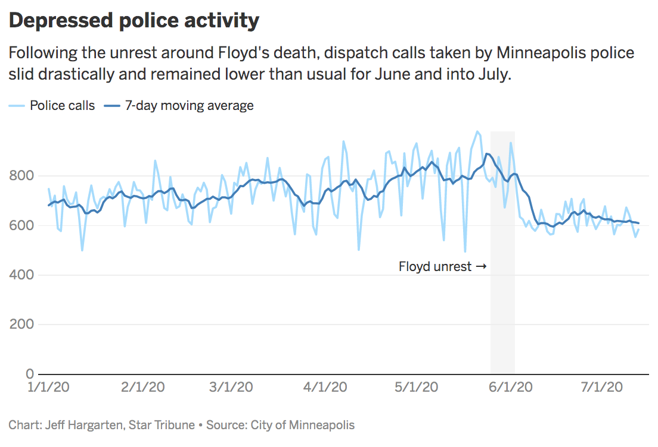

[View this chart in DataWrapper](https://datawrapper.dwcdn.net/VmoIj/1/)

**The 911 gap is larger – but officers are also initiating far less**

When measuring weekly 911 calls received by Minneapolis Emergency Communications Centers (MECC) against total MPD calls (911 or otherwise), there’s always a gap, since a certain amount of MECC service requests get filtered out, transferred elsewhere or assigned to different agencies aside from police. Many MPD calls are also officer-initiated and don’t involve 911. This means there’s always a far greater volume of 911 than MPD calls, typically in that 20% to 30% more range.

But the gap this year, following the end of unrest, is much larger than last year when comparing weeks since mid-March to mid-July. The largest gap was during the first two weeks following Floyd’s death, but they never bounced back to previous levels. In other words, instead of there being 20-30% more 911 calls than MPD calls, the gap is more like 50% this summer.

|  |  |  |  |
| --- | --- | --- | --- |
|  | 2019 gap | 2020 gap |  |
| **Week 1** | 19% | 31% | Mar 15-21, 2020 |
| **Week 2** | 20% | 30% | Mar 22-28, 2020 |
| **Week 3** | 19% | 23% | Mar 29-Apr 4, 2020 |
| **Week 4** | 33% | 25% | Apr 5-11, 2020 |
| **Week 5** | 27% | 22% | Apr 12-18, 2020 |
| **Week 6** | 31% | 23% | Apr 19-25, 2020 |
| **Week 7** | 34% | 28% | Apr 26-May 2, 2020 |
| **Week 8** | 30% | 25% | May 3-9, 2020 |
| **Week 9** | 34% | 23% | May 10-16, 2020 |
| **Week 10** | 30% | 29% | May 17-23, 2020 |
| **Week 11** | 32% | 70% | May 24-30, 2020 |
| **Week 12** | 32% | 73% | May 31-Jun 6, 2020 |
| **Week 13** | 30% | 52% | Jun 7-13, 2020 |
| **Week 14** | 32% | 56% | Jun 14-20, 2020 |
| **Week 15** | 29% | 51% | Jun 21-27, 2020 |
| **Week 16** | 31% | 54% | Jun 28-Jul 4, 2020 |
| **Week 17** | 25% | 51% | Jul 5-11, 2020 |

911 calls overall this year are mostly comparable to last year at this time, with only very slight declines, mostly due to COVID-19, according to MECC.

So when isolating only MPD calls that come from 911, we see they’re still lower than last summer, but the dropoff isn’t quite as steep.

Instead, the biggest decline in police calls are among those that are officer-initiated.

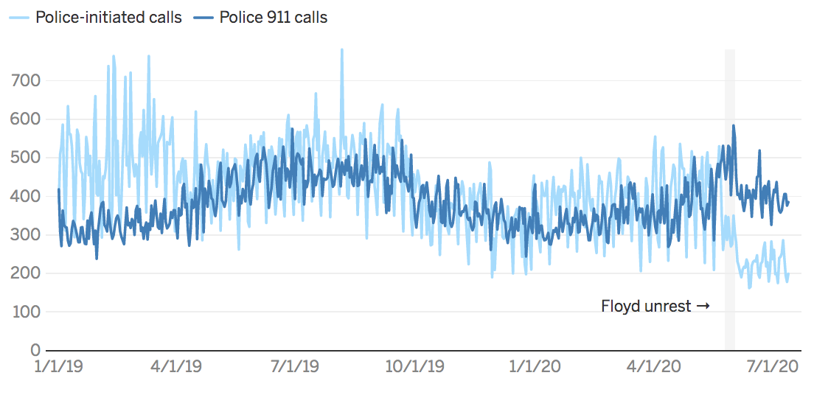

[View this chart in DataWrapper](https://datawrapper.dwcdn.net/WQHi4/2/)

While 911 response represented less of MPD’s activity in June and July than last year, officer-initiated calls fell by more than half over the summer.

**Changes in MPD activity, by type and month between 2019 and 2020**

|  |  |  |
| --- | --- | --- |
|  | **Officer-initiated** | **Police 911 calls** |
| **Jan** | **-20.8%** | **+3.0%** |
| **Feb** | **-19.8%** | **+4.8%** |
| **Mar** | **-28.0%** | **+8.4%** |
| **Apr** | **-3.6%** | **-5.2%** |
| **May** | **-13.6%** | **+1.7%** |
| **Jun** | **-51.9%** | **-10.6%** |
| **Jul** | **-56.1%** | **-16.2%** |

**There’s more gunfire, but less of everything else**

Comparing the volume of police calls and incidents by month from 2019 to 2020 shows a dramatic reduction in every metric except gunfire reports, as a percent change. Police calls have been down to a degree all year, but not to the extent they are now.  
  
**Changes in MPD activity by month between 2019 and 2020**

|  |  |  |  |  |  |
| --- | --- | --- | --- | --- | --- |
| **month** | Police calls | Police incidents | Police stops | Use-of-force | Gunfire reports |
| Jan | -11.5% | +26.2% | -5.4% | -14.5% | -16.4% |
| Feb | -9.9% | +29.8% | +32.3% | +4.6% | -6.9% |
| Mar | -13.6% | +32.0% | -0.0% | +28.8% | +58.4% |
| Apr | -4.3% | -7.1% | +5.0% | -23.0% | +25.7% |
| May | -6.1% | -9.5% | -0.7% | +19.5% | +136.7% |
| Jun | -31.5% | -13.3% | -50.5% | -64.6% | +224.0% |
| Jul | -37.0% | -14.1% | -70.7% | -79.0% | +168.4% |

Note: numbers run through July 13th for both years

Types of calls police respond to have changed as well – with the largest drops seen among proactive activities like directed patrols, traffic stops and drug-related enforcement – compared to 2019. Some of those had been down most of 2019, perhaps due to COVID-19.

Last year in June saw 3,000+ directed patrol calls, but only about 300 were dispatched this year.

**Changes in MPD assigned call types by month between 2019 and 2020**

|  |  |  |  |  |  |  |
| --- | --- | --- | --- | --- | --- | --- |
|  | **Jan** | **Feb** | **Mar** | **Apr** | **May** | **Jun** |
| Proactive | -83.5% | -73.2% | -73.6% | -56.3% | -64.1% | **-95.1%** |
| Traffic | +6.9% | -36.1% | -46.6% | -14.9% | -9.2% | **-86.3%** |
| Drugs | +25.8% | +70.0% | +47.3% | +16.2% | -1.9% | **-66.8%** |
| Weapons | -36.1% | -40.4% | -27.9% | -46.2% | -28.8% | **-63.1%** |
| Other | +79.4% | +56.4% | +54.5% | +49.3% | +23.5% | **-57.5%** |
| Missing/lost person | -25.5% | -10.5% | +0.5% | -44.1% | -43.4% | **-57.1%** |
| Disturbance | -15.3% | -3.1% | -0.1% | -0.5% | -2.0% | **-56.2%** |
| Alarm response | -8.8% | -2.2% | -5.3% | +66.8% | +30.5% | **-55.3%** |
| Welfare check | -7.0% | -12.2% | -7.2% | -5.4% | -10.6% | **-51.2%** |
| Unknown | +12.6% | +31.9% | +8.3% | -2.2% | -7.1% | **-49.2%** |
| Assist | +28.1% | +32.2% | +18.0% | +1.1% | +10.7% | **-43.7%** |
| Property crime | +12.4% | -6.9% | -6.6% | -22.6% | -3.0% | **-41.8%** |
| Suspicious person | -2.6% | +14.7% | +7.7% | +1.4% | -12.7% | **-39.9%** |
| Domestic dispute or assault | -3.6% | +0.8% | +21.2% | -0.9% | +6.4% | **-35.6%** |
| Emotionally disturbed person | +5.9% | +20.9% | +16.7% | +26.4% | -10.7% | **-23.9%** |
| Medical | +5.3% | +51.7% | +15.7% | +8.0% | +17.6% | **-20.1%** |
| Violent crime | +16.6% | +38.3% | +42.4% | +9.5% | +26.6% | **-4.9%** |

Police use-of-force as a rate per 1,000 calls has dropped from 10 in January to 3 in June and July so far.

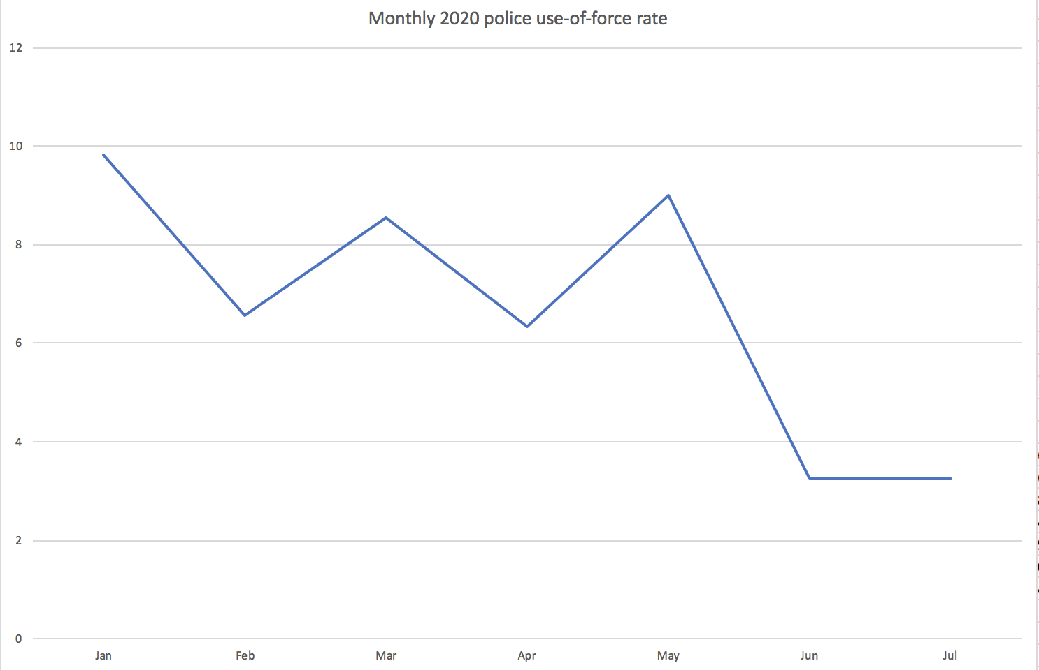

**Activity is down everywhere but the Fourth**

This summertime reduction in police calls is seen in nearly every MPD precinct. A far less active summer in Downtown likely drives the First’s numbers down, suggesting some of this trend could be related to COVID-19.

Meanwhile, the Fourth Precinct is the exception, and has seen a busier summer for police calls than last year, seemingly related to gun violence and homicides.

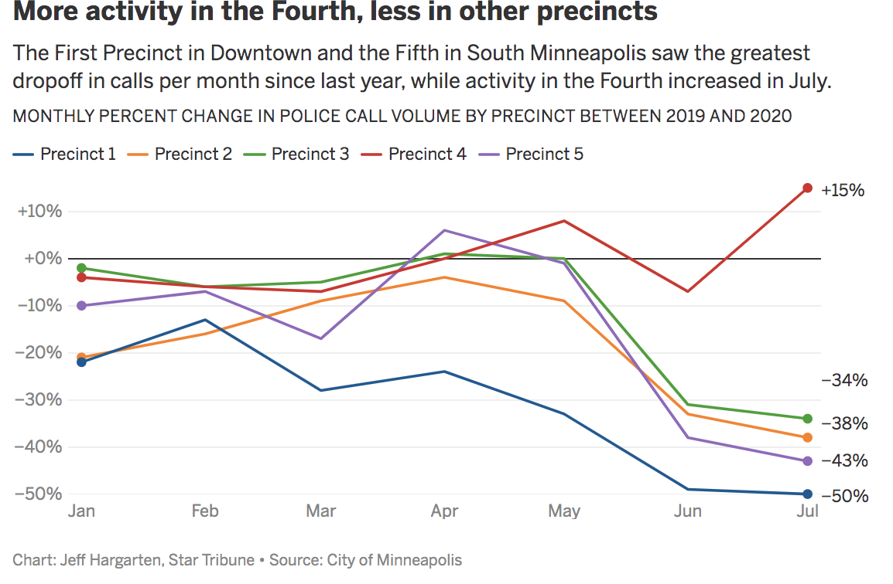

[View this chart in DataWrapper](https://datawrapper.dwcdn.net/ke1gz/1/)

**Response times have somewhat slowed down**

Also, average daily response times – measured in hours between when a police unit is assigned by dispatch and when that unit actually arrives on scene – has increased since June 2.

Most calls have an elapsed response time of zero, so for averages to rise to this degree signals some significant delays.

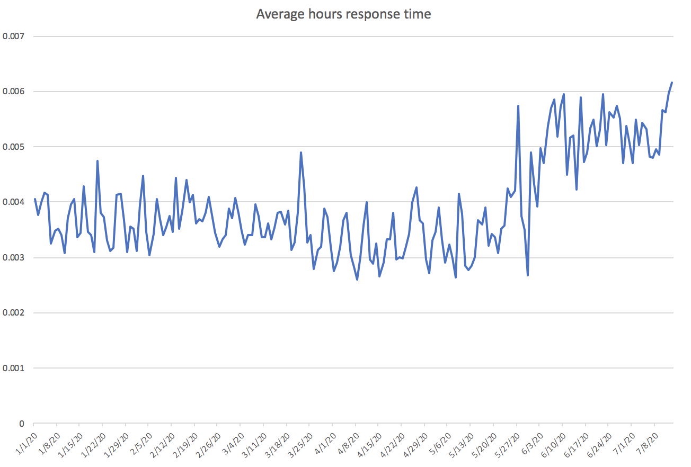

[More on emergency response times](https://www.startribune.com/emergency-callers-wait-longer-for-police-responses-at-minneapolis-border/506438091/)

**Other agencies see shifts too, but in opposite directions**Activity among other agencies like the Minneapolis Fire Department and 311 have also changed from last year, though the reasons why aren’t immediately apparent.

311 calls were up more than 4000% in May, but a significant portion were dated before Floyd’s death.

To what extent the 1500% boost in June is related to people using them as an alternative to police is difficult to determine since types of calls cover a wide spectrum.

We need to understand this data better to say anything definitive about it.

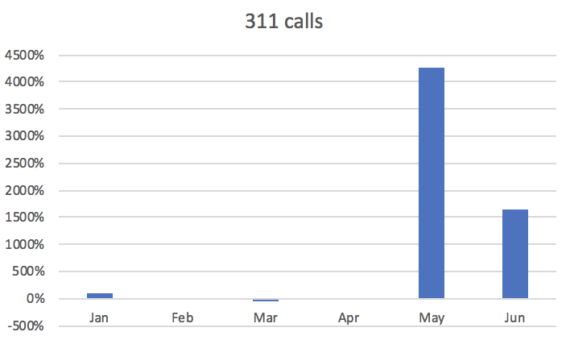

Changes to MFD calls have been consistently and significantly down each month, likely due to COVID-19’s impact.

However July’s fire department call volume so far looks more like 2019 much closer to usual levels.  
  
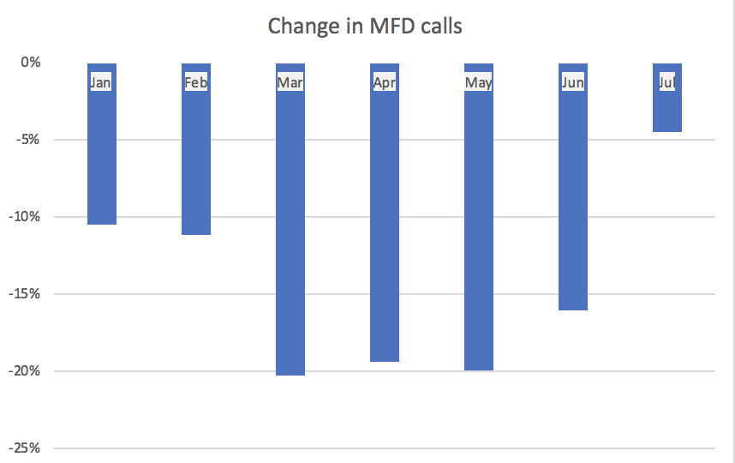

**Additional observations:**

* Regardless of specific explanations behind these trends, it’s clear the relationship and dynamic between Minneapolis residents and the city’s police department has changed, even without palpable public policy shifts.
* Much of the drop in activity involves activities police take upon themselves, rather than responses to needs of residents, suggesting this is less a slowdown/protest and more internal challenges facing a department in crisis.
* Understanding this is largely contingent on grasping how MPD officers usually spend their time. We have 2018 and 2019 data as reference points for this, which seem like reasonably normal years for police activity in Minneapolis.
* Despite a surge in shootings and gunfire reports, violent crime calls were still slightly down in June from last year.
* We see that MPD officers are assisting other agencies less, not sending squad cars as often to medical and fire emergencies.

**Further questions:**

The data doesn’t answer all its own questions. Prior Star Tribune reporting does get at some of this, but these issues jump to mind:

* To what extent do police staffing issues (requested leave, disability benefits, etc) contribute to these trends?
* To what extent are these reductions in police activity due to officers changing law enforcement priorities?
* Is a work slowdown or other form of protest among MPD officers involved?
* Are concerns over officer safety following Floyd’s death affecting how officers respond to calls? (DPS dispatchers suggested to us this may have an effect)
* How much is related to ongoing effects of the COVID-19 pandemic? (canceled events, less Downtown activity, etc. MECC suggested it plays a role)
* What impact has MPD losing various contracts with city and business entities had on these numbers?
* To what extent are Minneapolis residents simply calling the police less? Getting all 911 calls may answer this for us.

**Some narrative reporting:**

Defunded or not, the Minneapolis Police Department is already changing its approach to policing in the wake of George Floyd’s death and monthslong protests.

During a historic moment for the city and time of year typically at the peak of crime, the department is recording and responding to fewer incidents, according to dispatch data obtained by the Star Tribune

Incidents involving police use-of-force collapsed by 65% in June, police stops declined by 50%, while dispatch calls and police incidents dropped by more than 30%.

At the height of unrest following Floyd’s Memorial Day death, criminal incidents recorded by police spiked to 180 on May 28 – an unprecedented peak for the entire year – then depleted the first week of June.

While police stopped 212 vehicles June 1, over the next few days the number of stops dropped to levels lower than the previous months plagued with the pandemic and stay-at-home orders that significantly reduced traffic.

Gun violence, however, continues to soar.

The trend mirrors what happened after Jamar Clark was killed by Minneapolis police in 2016. In the days of protests, [data suggested a police slowdown while violent crime persisted](https://www.startribune.com/minneapolis-officers-face-accusations-of-slowdown/378529735/).

This could possibly be attributed to what is known as the “Ferguson effect,” a term coined after the 2014 police killing of Eric Garner. It describes an uptick in violent crimes following a high-profile police killing. Along with that rise, however, is a pullback in officer action.

Following Floyd’s death, Minneapolis police responded to 32% fewer calls for service. The question remains if this means residents are calling police less or if police stopped responding to calls made. Dispatch data does not account for placed calls police did not respond to.

Leslie Bowden, born and raised in south Minneapolis, has called police plenty of times with no response. She can see the Floyd memorial on 38th and Chicago from her front yard, and that might be why this time around things feel so different. After Clark’s death and Philando Castile, she still saw police respond to her neighborhood, though they weren’t “frequent fliers.” But now she said it’s a completely different neighborhood.

“It wasn’t like this where we felt like we became the enemy to police,” she said.

A big difference with Floyd unrest, unlike Castile or Clark, is the active threat of the police department dissolving.

Bowden said she calls police as a last resort, mostly when she hears gunshots, and it seems like a last resort for police to respond. Residents are left to “fend for yourself,” she said.

“Police murdered a man in our neighborhood and then they just all fell out and left us alone to figure out our own as far as protecting our neighborhoods,” she said. “You feel isolated, like you're in a war zone sometimes but there's no one helping us … I don't see the police doing anything. I'm sitting here on the busiest street in South Minneapolis and I haven't seen a single police car. They have just disappeared on us.”

The only patrol she saw during the height of unrest was the National Guard. So residents started patrolling the area themselves and messaging each other on WhatsApp rather than calling the police. When she does dial 9-1-1 about a shooting, dispatchers tell her they’re hearing similar calls, but never say they’re handling the situation.

“I’m calling every time I hear a gunshot. I’m not afraid to call,” she said. “I never was one to call the police on anything insignificant. They obviously don’t care about our lives here.”

Police have adamantly denied standing down since Floyd’s death May 25, but data and some residents’ experience like Bowden suggests otherwise.

Derek Iverson, a supervisor with Minneapolis 9-1-1, said there are “fake 9-1-1 calls” and cases of cops avoiding calls where “people try to bait them into confrontation or attack them.”

“We’re not doing anything different in terms of how we take calls or enter calls. The only real difference is sometimes the way in which officers are having to be careful or approach the situation more carefully,” he said.

Ivereson said dispatch call volume “rose initially when the largest mayhem was happening,” and there could be a number of reasons why it dropped afterward. He said colleagues didn’t feel safe staying in their own homes and relocated to relatives or friends and hotels outside of the city. He speculated how many others living in Minneapolis did the same.

The pandemic also played into the drop in calls and incidents, he added. With more people in quarantine at home, he expected to see a decrease in burglaries, for example.

Tabitha Montgomery, executive director of Powderhorn Neighborhood Association, offered several potential causes of the decline.

She described a spectrum of people hesitating before calling 911 for different reasons, such as trying to weigh the importance of the call against what could happen if a situation escalates, or “communal shame or blame” for placing that call.

Montgomery doesn’t believe that hesitation will continue if alternatives to 9-1-1 aren’t communicated. She said there aren’t enough resources to reduce instances of 9-1-1 calls.

“I believe that there's likely a correlation between the reduction in 9-1-1 calls to this current moment, this moment where residents and the police department and elected leaders are all beginning to rethink, reconsider how policing is approached in Minneapolis,” she said.

The city council’s ongoing actions to seek a charter amendment to disband the department and replace it with the new community safety and violence prevention department could factor into the decision of whether to engage with police, she said.

“In the midst of understanding that, we're on the path of trying to figure out what change looks like without being explicit about what is the role of MPD, I can see right now how that could be likely influencing people's behaviors,” she said.

“We have individual agency, we have our own ability to assess danger or harm,” she said. “People should not, at this point, in my opinion, believe that MPD is not an option, in cases of emergency because there are no alternatives in this current moment that can support everyone in the city.”

She said the reduction in calls and police incidents is clearly revealing that people are responding to this moment differently.

Her association sent out one email to residents after Floyd’s death asking them to be mindful of dialing 9-1-1, but it didn’t advise neighbors to not call the cops altogether.

Other neighborhood associations, such as Tangletown, Downtown and Nokomis East, haven’t taken the approach of asking neighbors to avoid calling 9-1-1.

But one local organization, MPD150, is advocating for just that. In fact, the No. 1 step it says the community can take in dismantling the police department is to stop calling 9-1-1.

To build a “police-free future,” [MPD150](https://www.mpd150.com/wp-content/uploads/2019/07/10-ACTION-IDEAS-FOR-BUILDING-A-POLICE-FREE-FUTURE.pdf) said the No. 1 thing people can do is top calling police “when it’s clearly unnecessary.”

“An inconvenience for one person, once police are involved, can become a death sentence for another person,” according to the organization.

Dr. Ronal Serpas, criminal justice professor at Loyola University New Orleans worked 34 years in law enforcement, including as Police Superintendent in New Orleans from 2001 to 2014. Serpas offered three reasons for the decline in police activity and calls for service, but acknowledge COVID-19 as an unusual variable figuring into the decline.

“For the many days following the death of Mr. Floyd, a significant percentage of the police department was likely taken away from its normal proactive duties. The detectives are often put into uniforms to help have more people in place. And that can go on behind the scenes actually for a lot longer than you might think because as a police department continues to analyze and try to digest intelligence of what's going on around the community in the issues associated with these protests, they may very well be continuing to hold a significant percentage of their available workforce kind of like in place.

In the Ferguson era, he said there was a lot of redirecting happening under the scene. “And that can have that can have a hangover effect to three, four weeks,” he said. Police do less patrolling and instead stage in a static location to be more visible.

Another thing that Serpas said can be pervasive in these situation is compensation time to make up for a surge in overtime in the department.

“When you have a lot of police officers that are working extended hours in the beginning of a crisis like this, they end up creating a tremendous amount of overtime costs that some cities use comp time to pay it off,” he said. “You have certain financial realities that are going to occur in the aftermath that are not intended to reduce public safety, but they could reduce the number of people available, because you just don't have the money to pay them.”

Serpas added that comp time can also be for officer who are just “worn out” because the protests are running 24/7 initially

The other thing that can happen in the community is people “self-regulating” calls for service for different reason: either they don’t trust police or don’t want to be a burden.

“People think the police have far too many important things to deal with or people just don't have confidence in police because of these effects going on,” he said.

As for the rise in violent crimes like shootings, Serpas said career criminals are taking advantage of an overworked, busy police department.

“They are very attuned to the police's inability to do the normal practices of searching out warrants and dealing with criminal investigations and creating cases, they're very well aware … And they take advantage of it.”